AXOOM Gate

Configuration Guide

for
Email Messaging
Plugin 079

Version Number 1
September 30, 2018

Table of Contents
Chapter 1 Introduction to AXOOM Gate Plugins 3
1.1 Overview 3
1.2 About AXOOM Gate 3
1.3 About Plugins 3
1.4 Plugin Deployment Patterns 4
1.5 The Plugin Dashboard 4
Chapter 2 Connecting to Messaging Server 6
2.1 About the Messaging Plugin 6
2.2 Login to AXOOM Gate 6
2.3 Accessing the plugin dashboard 8
2.4 Adding targets for messaging 9
2.5 Accessing other settings groups 11
Appendix A: AXOOM Gate Navigation Icons 13

Introduction to AXOOM Gate Plugins

Overview
This document covers configuring the Messaging plugin running in AXOOM Gate (and compatible platforms).

About AXOOM Gate
AXOOM Gate provides remote and mobile access to industrial production equipment in a secure, efficient, extensible manner. In the interest of operational efficiency and reduced complexity, industrial systems are often configured with data security features disabled. With its built-in, IT-friendly data security settings, AXOOM Gate seamlessly links production systems with office and mobile systems without compromising either factory operation or IT data security requirements.

The installation folder for AXOOM Gate in Microsoft Windows is: C:\Program Files (x86)\AXOOM\AXOOM-Gate. The main executable program is AxoomGateService.exe, which can run both as a Windows service (akin to a Linux daemon) as well as a command-line program.

About Plugins
An AXOOM Gate plugin is a dynamic-link library (DLL) built with the C-Labs™ C-DEngine™ SDK. Plugins must have a filename with a prefix of CDMy or C-DMy (examples: CDMyCharts.dll and C-DMyNetwork.dll).

Plugins enable custom features in AXOOM Gate. The many types of plugins include:
- Configuration Plugins – provide a user interface for configuring hardware or software.
- Connector Plugins – enable a communication channel between AXOOM Gate nodes.
- Device Plugins – enable connections to and data collection from local sensors and devices directly connected to the system running AXOOM Gate.
- User Interface (NMI) Extension Plugins – provide custom controls and other user interface extensions to AXOOM Gate.
- Protocol Plugins – support industry standard protocols like OPC / UA, Modbus, MT Connect, serial ports, and proprietary programmable logic controllers (PLCs) such as the Siemens S7.
- Service Plugins – support other plugins.

As of this writing, there are over 100 plugins. AXOOM Gate v2.102 ships with 22 plugins (see Appendix B for a complete list). Most of these plugins exist to enable live capture of one or more data points from a running system. Such data capture plugins all share a common pattern in terms of how they are configured.

Plugin Deployment Patterns
To simplify the proper plugin deployment and configuration, this deployment pattern applies to almost every AXOOM Gate plugin:
- Secure login – A username and password are required to log into AXOOM Gate.
- Plugin button on home page – All plugins have a button on the AXOOM Gate home page, the first page displayed when you log into AXOOM Gate (see Figure 2.3). Click the plugin’s button to access the plugin dashboard.
- Plugin dashboard – A plugin dashboard displays all configured items (connections, object, devices, sensors). A plugin dashboard also has a button for creating new items (see Figure 1.1).
- Editing existing items – Configuring connections involves setting network or device addresses.
- Once connections are established, you pick specific data points – also known as “properties” – to read.
- Such properties are grouped together as “Things,” such as you might expect to find in a package that was created to help connect to the “Internet of Things.”

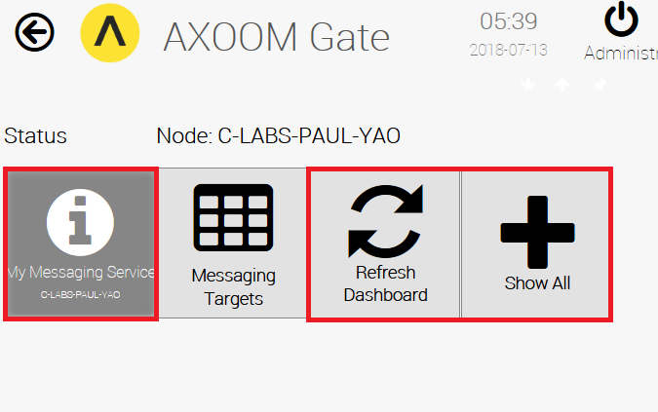
Figure 1.1. The Messaging plugin dashboard.

The Plugin Dashboard
A plugin’s dashboard (see Figure 1.1) provides the primary plugin interface. All “live” items appear at the top of a plugin dashboard. A series of buttons appears at the bottom of the plugin dashboard. In the dashboard shown in Figure 1.1, red rectangles identify the three standard dashboard buttons:
1) About button: The button with the circled “i” is the About button. Click for details on the dashboard. The button color reflects the status. Status colors, associated status code, and meaning of the status, are summarized here:
  - Gray (0): Idle.
  - Green (1): Active / Ok.
  - Yellow (2): Warning.
  - Red (3): Error.
  - Blue (4): Starting / Setup / Ramp Up.
  - Brown (5): Design / Engineering / Configuration.
  - Purple (6): Shutdown.
  - Black (7): Unknown / Unreachable.
2) Refresh Dashboard button: Reloads the dashboard with latest values.
3) Show All button: Open all forms and tables associated with the plugin.

Figure 1.2 shows the default image on a table button. Click a table button to view and edit a table of items managed by the plugin. For example, you can add new items, edit existing item properties, or delete items.
Figure 1.2. Buttons with this table icon enable viewing and editing tables of plugin items.

Establishing a Connection to a Messaging Server
This chapter covers connecting to an SMTP email server using the Messaging plugin.

About the Messaging Plugin
The messaging plugin provides the ability to establish email notifications when events of interest occur within AXOOM Gate or within a plugin running within AXOOM Gate.

Login to AXOOM Gate
- Enter this URL, http://localhost:8701/nmi, in a web browser. The following login page appears:
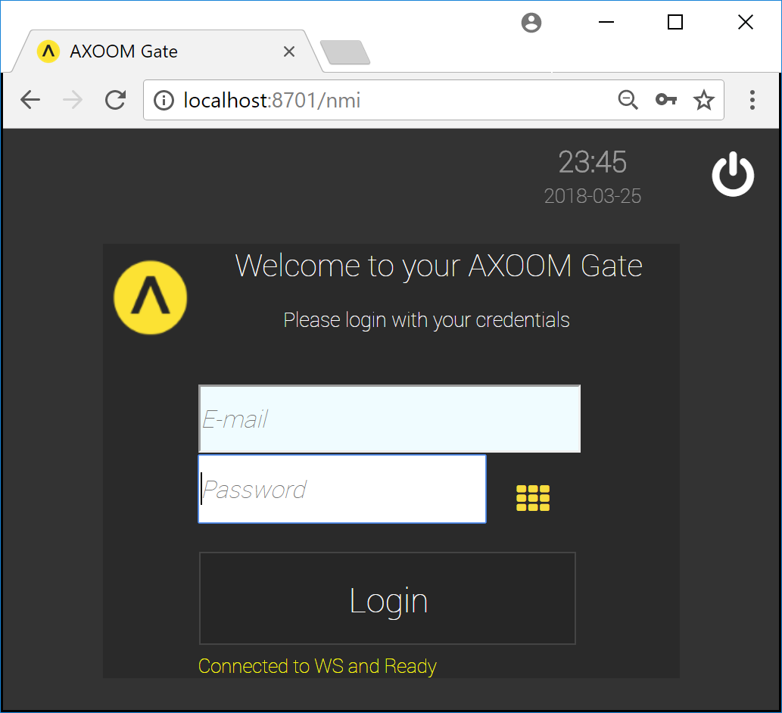
Figure 2.1. The dark scheme for the AXOOM Gate login page.
- This URL, http://localhost:8701/lnmi, enables the “light” display scheme:
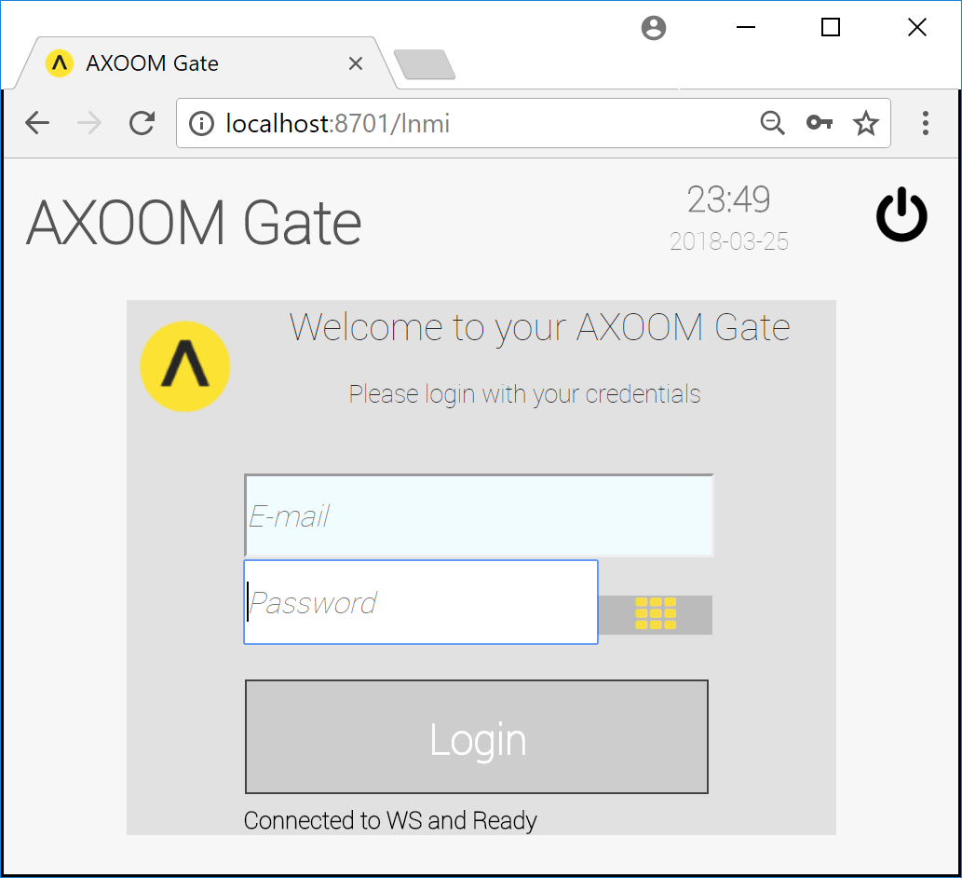
Figure 2.2. The light scheme for the AXOOM Gate login page.
- You see the AXOOM Gate home page, as shown in Figure 2.3.
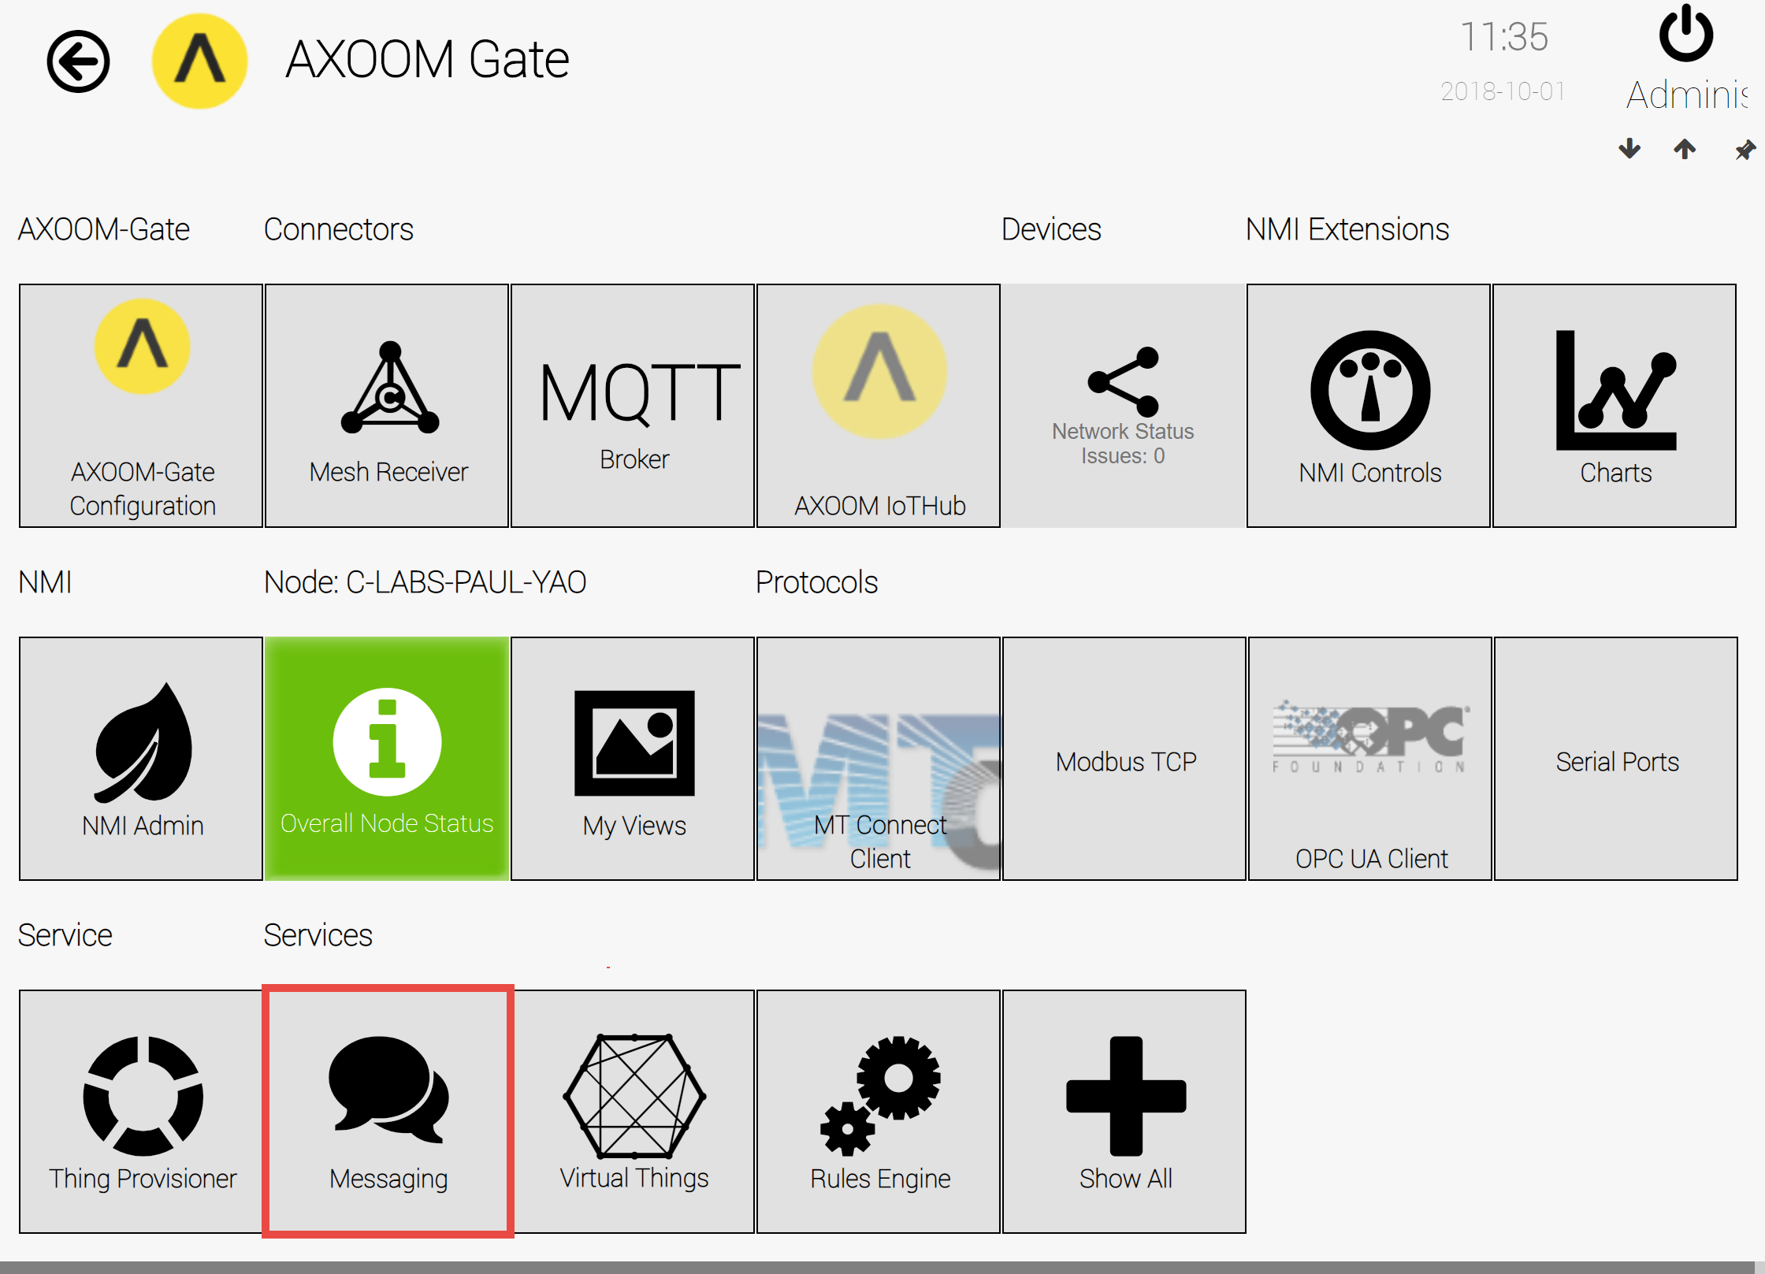
Figure 2.3. The “Messaging” plugin button highlighted on the AXOOM Gate home page.

Accessing the plugin dashboard
- When you click the Messaging button, the Messaging plugin dashboard appears (see Figure 2.4).
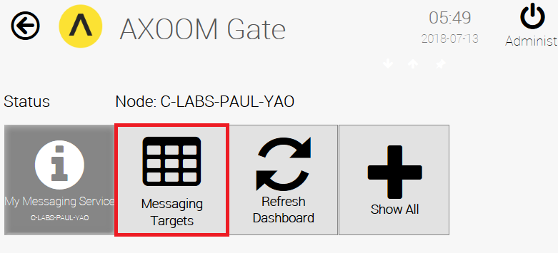
Figure 2.4. The Messaging plugin dashboard.
- Setting up the Messaging plugin starts with defining messaging targets. To see the current set of targets and to add new ones, click the Messaging Targets button (highlighted in red).

Adding Messaging Targets
- Figure 2.5 shows the Messaging Targets page. To add a target, click the Add a new Messaging Target button.
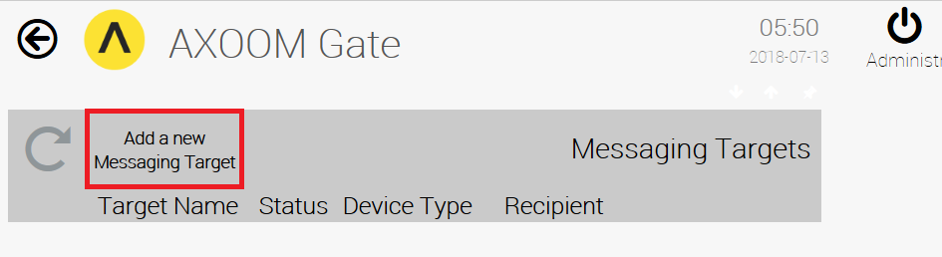
Figure 2.5. Click “Add a new Messaging Target” to add a recipient.
- An empty row appears, ready for new Messaging Target details (see Figure 2.6).
- Enter a value in the “Target Name” and “Recipient” fields, then click the checkmark () to save your work. A new Messaging Target is added to the list (see Figure 2.7).

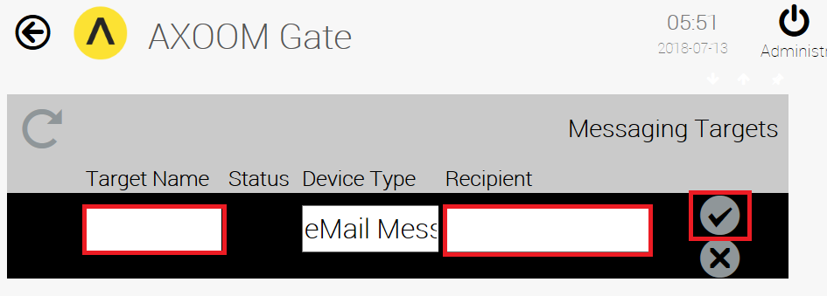
Figure 2.6. Enter Target Name and Recipient. Click checkmark to save.
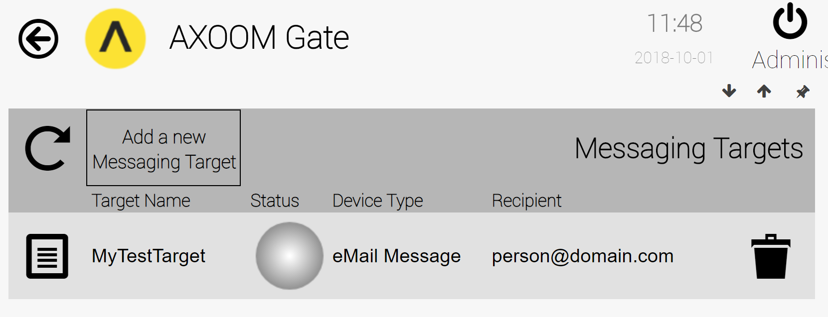
Figure 2.7. A Messaging Target.
The round status light will turn green when a message is sent. Details about each column in the Messaging Target list are provided in the following table:
Column | Description
 | The Properties icon. Click to view and edit additional message settings.
Target Name | Friendly name of the messaging target.
Recipient | Email address of the recipient.
Status | The status light is not used in the messaging plugin.
Device Type | The Device Type is always eMail Message.
Recipient | The email address of the email recipient.
 | Trash can. Delete item on current row. After deleting, click the Refresh button ().

Setting Messaging Target Properties
After you create a messaging target, click the properties button (). Figure 2.8 shows the settings page that appears, with both settings groups open. In the Message Header group, there are four values to provide:
- From Address – The email address for the email sender.
- Subject – The text for the email message.
- Enter a recipient – The email address for the email recipient, which you can edit at any time.
- Enter a Message – The text of the email message to send.
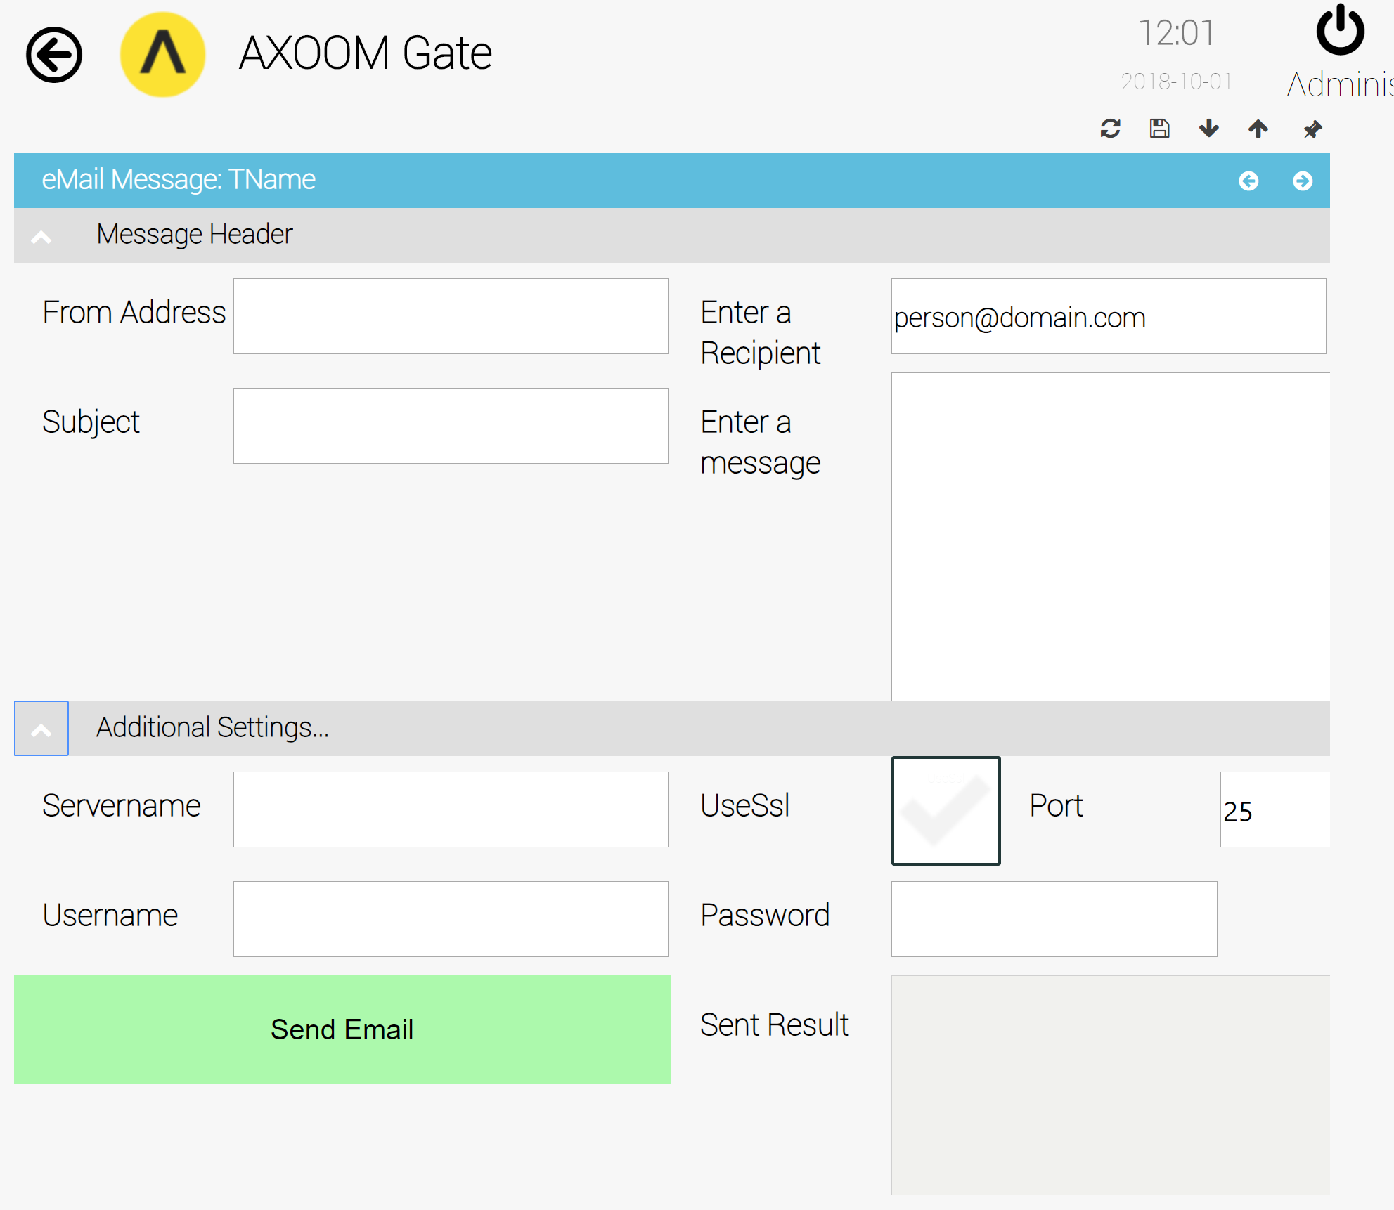
Figure 2.8. All groups showing on server properties page.
You must set up values in the Additional Settings group in order for email messages to be sent. The following fields are included:
- Servername – Provide the name of an SMTP email server. Examples: smtp.gmail.com, smtp.office365.com.
- UseSSsl – Whether to use SSL/TLS when sending the email message.
- Port – Some common port numbers for SMTP include 25, 2525, or 587 for unsecure messaging and 465, 25, 587, or 2526 for secure SMTP.
- Username – A valid user name for connecting with the server.
- Password – A valid password for connecting with the server.
- Send Email button – Click this button to test your settings.
- Sent Result – A read-only field that displays the results of the last attempt to send email.

Appendix A: AXOOM Gate Navigation Icons
Here is a summary of the AXOOM Gate navigation icons:
Icon | Name | Comments
 | Home | Click to navigate to home page.
 | Back | Use instead of the browser’s built-in back button.
 | Refresh | Use instead of the browser’s built-in refresh button.
 | Properties | Click to view properties.
 | Trash Can | Delete an item.
 | Up arrow | Closes a group of controls.
 | Down arrow | Opens a group of controls.
 | Left arrow | Decreases the width of browser space used to display property groups.
 | Right arrow | Increases the width of browser space used to display property groups.

